**Lab Assignment 1: Spinning Up React Native App**

***GitHub repository:*** [***https://github.com/dreamerme/cprg303-assignments***](https://github.com/dreamerme/cprg303-assignments)

***Yuan lyu***

1. **System Requirements**
   1. CPU: Intel(R) Core(TM) i7-8650U CPU @ 1.90GHz 2.11 GHz
   2. RAM: 16.0 GB (15.9 GB usable)
   3. Windows Version: Windows 10 21H2
2. **Installation**
   1. Install NodeJS from Node.js.
   2. To ensure that you installed NodeJS successfully, open the Command Prompt (enter “cmd” on your taskbar’s search bar) and run a version check. Enter the following prompts:

>node -v

>npm -v

Each command should return your system’s version of NodeJS and Node Package Manager, respectively.

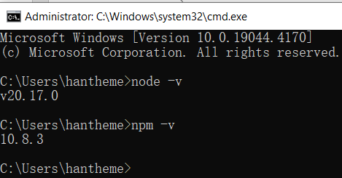

* 1. On your Command Prompt, enter **npm install expo-cli –global** or **npm install –global expo-cli**.

1. **Configuration steps & Project Creation**
   1. On your Command Prompt, navigate to your preferred directory for your projects by using the change directory command (cd).

>e:

>cd nodejs/expo/cprg303

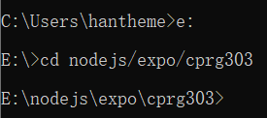

* 1. While in that directory, enter **npx create-expo-app TodoListApp** or **npx create-expo-app@latest TodoListApp** on your Command Prompt. This will download and extract the necessary project files.

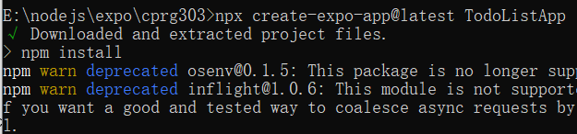

1. **Running the project**
   1. Using the cd command, move into the project directory.

> cd TodoListApp

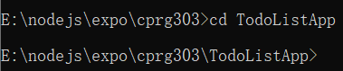

* 1. Open the project in VSCode by entering **code .**

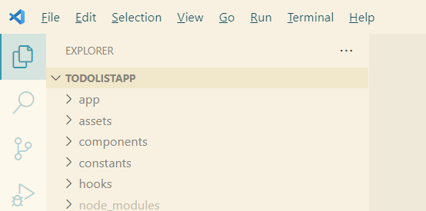

* 1. Type **npx expo start** or **npm start** to generate a QR code that you can scan with your mobile phone.

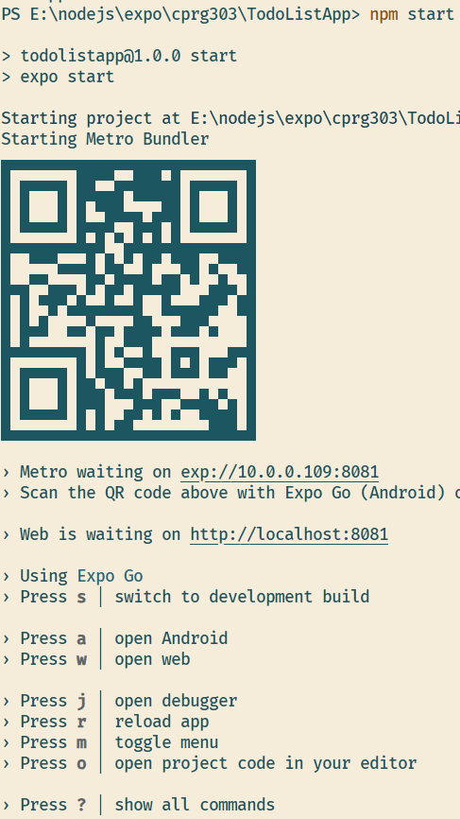

* 1. Press a to open Android

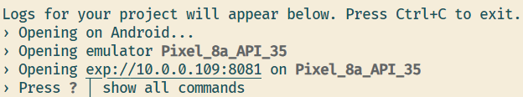

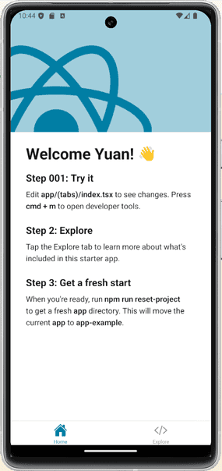

1. **Troubleshooting**

In case your app is not loading on Expo Go, ensure that your computer and your mobile phone are connected to the same network.

1. **Resources**
   1. **Expo Go Docs**: https://docs.expo.dev/
   2. **Node.js**: https://nodejs.org/en/
   3. **React Native: Setting up the development environment**: https://reactnative.dev/docs/environment-setup
   4. **Visual Studio Code:** https://code.visualstudio.com/